Introduction
FarmSmart SL is a digital agricultural marketplace system designed to connect farmers and buyers across Sierra Leone through a mobile and web-based platform. The system addresses the challenges faced by smallholder farmers who lack access to organised markets, fair pricing, and reliable buyers for their agricultural produce.
The system is developed as a Digital Public Good, meaning it is freely accessible, open-source, and designed to benefit the public. FarmSmart SL aligns with the United Nations Sustainable Development Goals, specifically SDG 2 (Zero Hunger) and SDG 1 (No Poverty), by empowering farmers with digital tools to improve their income and food distribution efficiency.
This report documents the complete software design of FarmSmart SL, including the Software Development Life Cycle model, system architecture, prototype development, project planning, license selection, and SDG relevance.

Software Development Life Cycle (SDLC)
SDLC Model: Agile Model
FarmSmart SL will be developed using the Agile Software Development Life Cycle model. The Agile model was selected because it supports continuous development and delivery through short, repeated cycles called sprints. This makes it ideal for FarmSmart SL, as the system requires regular feedback from farmers, buyers, and agricultural stakeholders in Sierra Leone to ensure the platform meets real-world needs.

Phase 1 – Planning
In this phase, the project team defines the goals and scope of FarmSmart SL. The main objective is identified as creating a digital agricultural marketplace that connects farmers with buyers across Sierra Leone. Team roles are assigned, resources are allocated, and a project timeline is established spanning Weeks 4 to 11.

Phase 2 – Requirements Analysis
The team gathers both functional and non-functional requirements. Functional requirements include user registration and login, product listing, search and filter functionality, order placement, and payment processing. Non-functional requirements include system security, mobile responsiveness, and ease of use for low-literacy users in rural areas.

Phase 3 – System Design
The system architecture is designed using a 3-tier model consisting of the Presentation Layer, Application Logic Layer, and Data Layer. User interface mockups are created using Figma, and the database structure is planned to store user profiles, product listings, and transaction records.

Phase 4 – Implementation
The system is built in two-week sprints. Each sprint focuses on delivering one working feature. For example, Sprint 1 covers user registration and login, Sprint 2 covers product listing and search, and Sprint 3 covers order placement and payment integration. This ensures steady progress and early detection of issues.

Phase 5 – Testing
After each sprint, the completed feature is tested for bugs and usability. Both unit testing and user acceptance testing (UAT) are conducted. Farmers and buyers are involved in UAT to ensure the system is practical and easy to use in a Sierra Leone context.

Phase 6 – Deployment and Maintenance
The completed system is deployed on a web server accessible via mobile and desktop browsers. The team monitors system performance and collects user feedback. Regular updates and improvements are made based on feedback received from the farming community.

System Architecture Design
Architecture Model: 3-Tier Architecture
FarmSmart SL is designed using a 3-Tier Architecture model. This architecture divides the system into three separate layers, each responsible for a specific function. This separation makes the system easier to maintain, scale, and secure. The three tiers are the Presentation Layer, the Application Logic Layer, and the Data Layer.

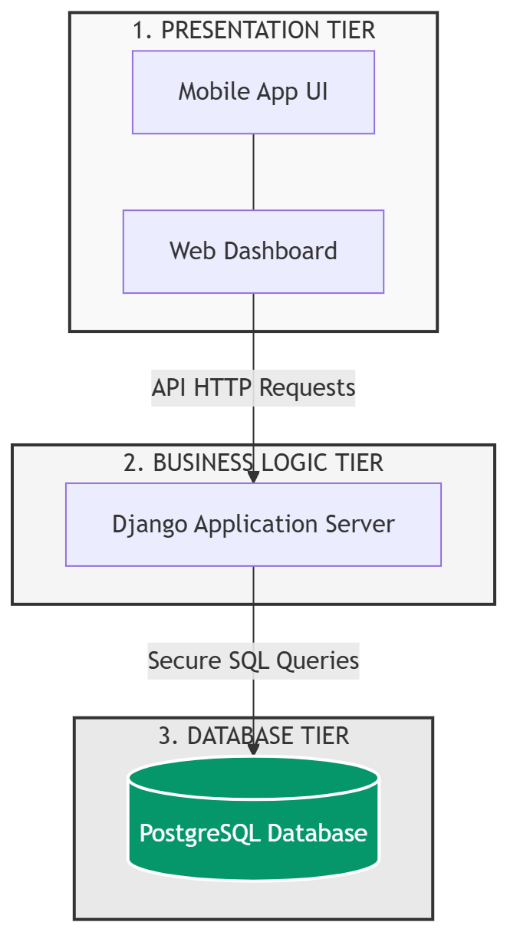

Flowgorithn technical Overview:
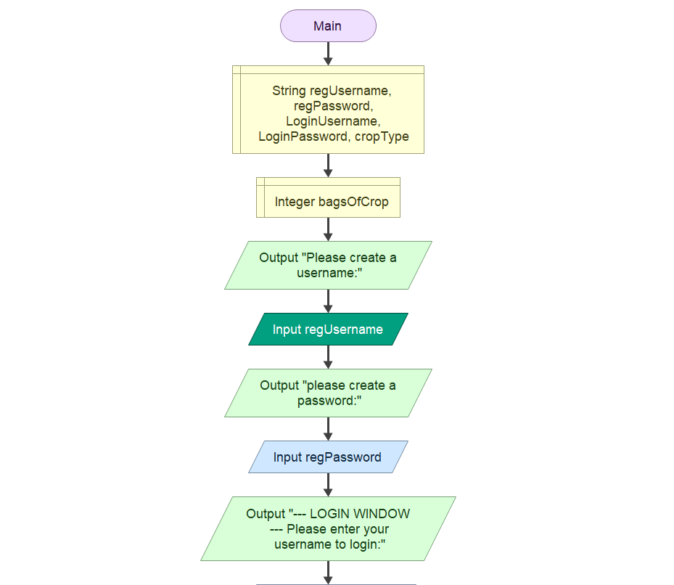
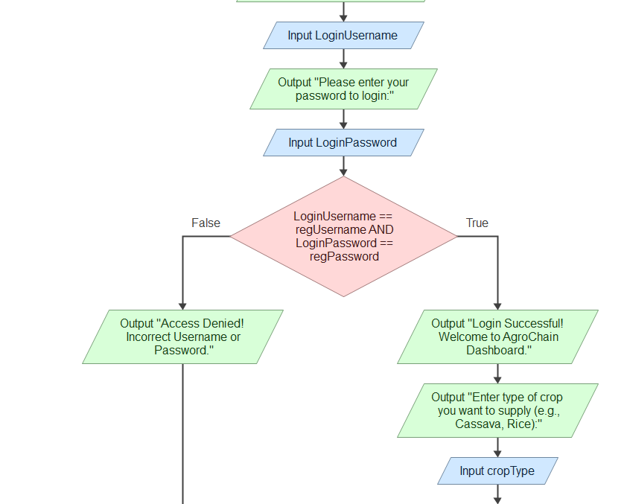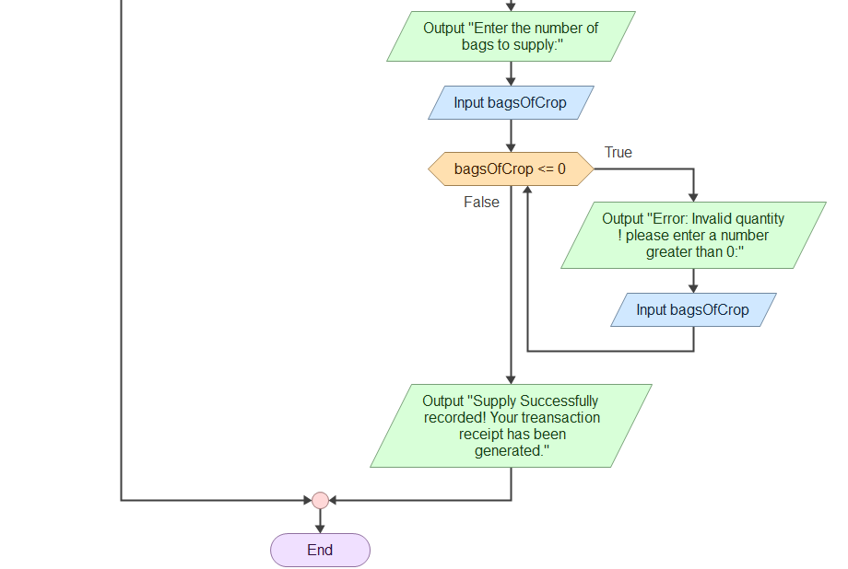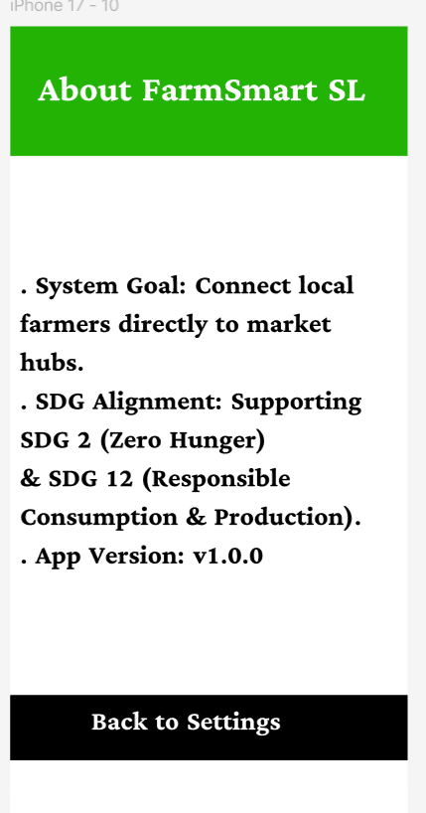

Tier 1 – Presentation Layer (User Interface)
The Presentation Layer is the part of the system that users interact with directly. FarmSmart SL can be accessed through two interfaces: a mobile application for Android and iOS devices, and a web browser for desktop and laptop users. This layer is responsible for displaying information to the user and collecting input such as login details, product searches, and order placements. All user requests are sent from this layer to the Application Logic Layer.

Tier 2 – Application Logic Layer (Web Server / API)
The Application Logic Layer serves as the brain of the system. It receives requests from the Presentation Layer, processes them, and returns the appropriate response. This layer contains five modules: the Authentication Module handles user registration and login, the Product Listing Module manages the display and upload of farm products, the Search and Filter Module allows buyers to search for specific products, the Order Management Module processes and tracks orders, and the Payment Module handles all financial transactions securely.

Tier 3 – Data Layer (Database)
The Data Layer is responsible for storing and retrieving all data used by the system. FarmSmart SL uses a MySQL Database to manage its data. The database contains four main tables: the User Table which stores farmer and buyer account information, the Product Table which stores all farm product listings, and the Orders Table which records all transactions and order details.

How the Components Interact
When a user opens FarmSmart SL on their mobile app or web browser, they send a request to the Application Logic Layer via HTTP. The logic layer processes the request and queries the MySQL database in the Data Layer using SQL. The database returns the required data to the logic layer, which then sends the response back to the user interface for display. This two-way communication ensures that the system functions smoothly and efficiently.
Prototype Development
The FarmSmart SL prototype was developed using Figma, a professional UI/UX design tool. A total of ten screens were designed to represent the key functionalities of the system. The prototype follows a clean, green-themed design that reflects the agricultural nature of the platform and ensures ease of use for farmers and buyers across Sierra Leone.

Screen 1 – Welcome / Login Screen
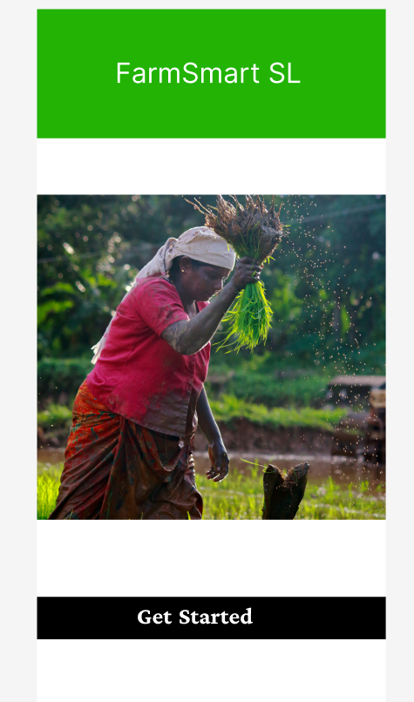
The welcome screen is the first screen users see when they open the application. It displays the FarmSmart SL logo and provides options to log in with an email and password or navigate to the registration screen.
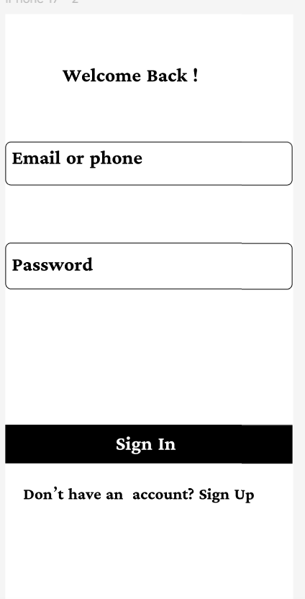

Screen 2 – Create Account Screen
The create account screen allows new users to register on the platform by providing their full name, email address, phone number, and password. Users can select whether they are registering as a farmer or a buyer.
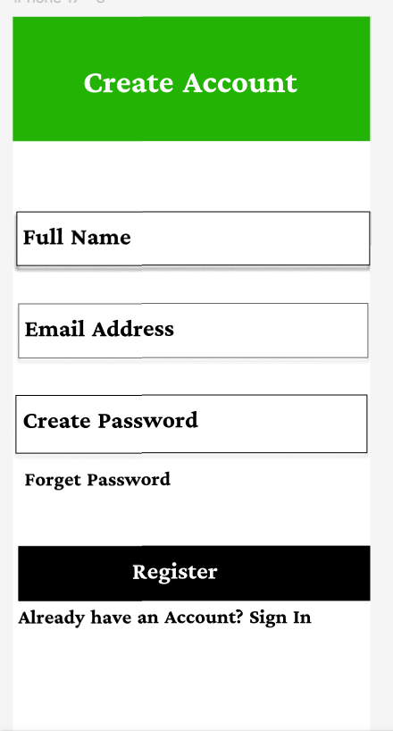

Screen 3 – Dashboard Screen
The dashboard is the main screen users see after logging in. It displays featured products, recent listings, and quick navigation links to key sections of the application such as Add Supply, Orders, and Profile.
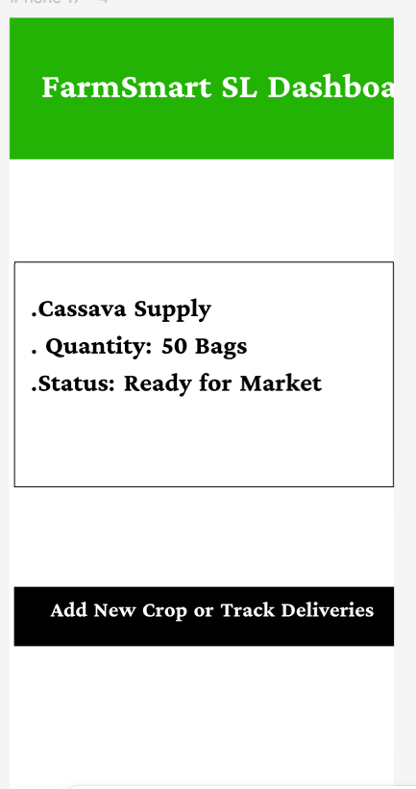

Screen 4 – Add New Supply Screen
This screen allows farmers to list new agricultural products for sale. Farmers enter the crop name, quantity, location, and expected price before submitting the listing to the marketplace.
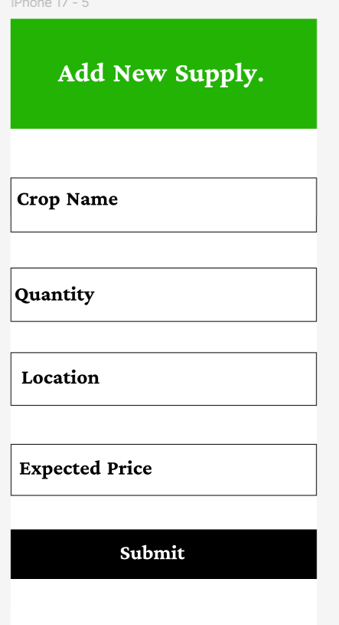

Screen 5 – Delivery Status Screen
The delivery status screen allows buyers to track the progress of their orders. It displays the current status of each order, including whether it has been confirmed, dispatched from the farm, is in transit, or has arrived at the market hub.
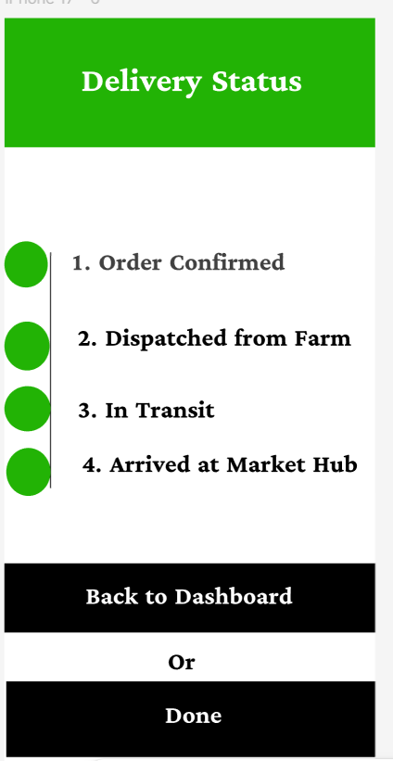

Screen 6 – Payment Receipt Screen
The payment receipt screen displays a summary of a completed transaction, including the order ID, item purchased, quantity, total payment amount, and payment status. Users can save or print the receipt.
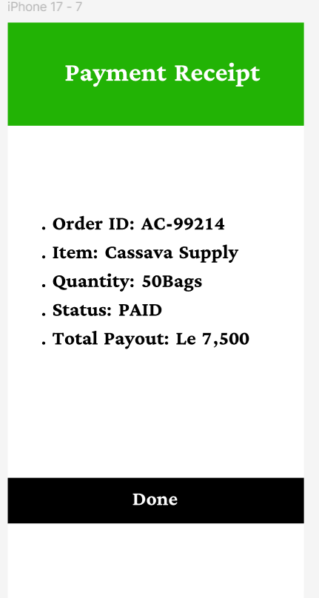

Screen 7 – My Profile & Wallet Screen
The profile and wallet screen allows users to view and edit their personal information, including their name, location, and account type. It also displays the user's wallet balance and provides options to log out or complete a payment.
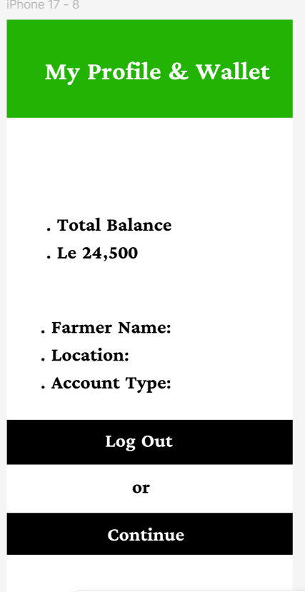

Screen 8 – Settings & Support Screen
The settings and support screen provides users with options to manage push notifications, change language preferences, report system bugs, and view the terms of service. It also displays the current version of the application.
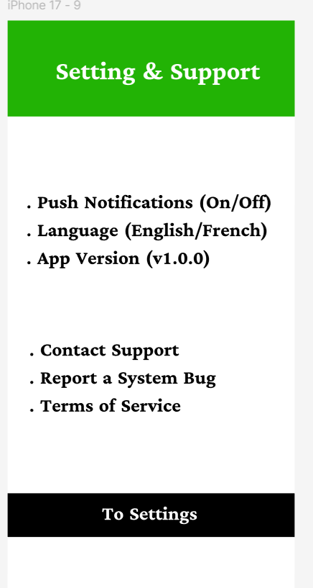

Screen 9 – About FarmSmart SL Screen
The about screen provides information about the FarmSmart SL platform, including its mission to connect farmers directly to the market, its SDG alignment, and the current version of the application.

Screen 10 – Search & Filter Screen
The search and filter screen allows buyers to search for specific agricultural products by name, category, price range, or location. Results are displayed in a clean list format with product images and pricing information.
- Project Management
The FarmSmart SL project was planned and managed using two key project management tools: a Gantt Chart and a Network Diagram (Activity on Node). These tools helped the team to organise tasks, set deadlines, identify dependencies between activities, and determine the critical path of the project.

Gantt Chart
The Gantt chart below illustrates the project timeline from Week 4 to Week 11. Each task is represented as a horizontal bar spanning the weeks during which it is carried out. Some tasks overlap to reflect the parallel nature of Agile development.

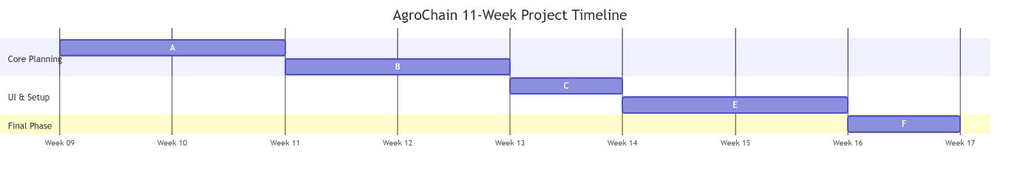

Network Diagram
3.0 Project Activity Network Diagram and Critical Path Analysis

​3.1 Introduction to Activity-on-Node (AoN) Methodology

​In project management and software engineering layout design, a project network diagram serves as a critical structural tool used to plan, schedule, and track the sequential logic of project milestones. To model the execution timeline for the AgroChain application development lifecycle, this project implements the formal Activity-on-Node (AoN) scheduling framework.
​As demonstrated in the class testing models found in file "6f9581c1-0c6e-401c-9db7-dcf988409af2", each engineering milestone is represented by a specific, circular tracking node split into a four-quadrant matrix. This standardized structural configuration systematically breaks down project data without using text-based time units like days or weeks. Instead, it relies purely on numerical progression tracking variables defined as follows:

​Top-Left Quadrant - Earliest Start (ES): The absolute earliest numeric point in the project timeline at which a specific milestone can begin once its preceding dependencies are fully completed.

​Top-Right Quadrant - Earliest Finish (EF): The earliest possible numeric point at which an activity can be concluded, calculated mathematically by adding the activity’s specific duration to its Earliest Start value (EF = ES + \text{Duration}).

​Bottom-Left Quadrant - Latest Start (LS): The latest possible numeric point at which an activity can begin without extending or delaying the final completion deadline of the entire project.

​Bottom-Right Quadrant - Latest Finish (LF): The maximum numeric point at which an activity must be fully completed to ensure subsequent dependent pathways are not bottlenecked.

​3.2 Task Sequencing and Network Logic Paths

​The operational framework of the AgroChain project is broken down into five core sequential nodes, which map out parallel and dependent pathways across the system lifecycle. The exact routing dynamics match the mathematical structures visualized in file "6f9581c1-0c6e-401c-9db7-dcf988409af2":

​Node A (Requirements Gathering): This serves as the mandatory baseline launch point for the network diagram. Because it is the originating task, its Earliest Start (ES) is initialized at 0. With a set duration of 15, its Earliest Finish (EF) lands exactly at 15. Because it is on the primary dependency track, its lower parameters mirror the top, yielding a Latest Start (LS) of 0 and a Latest Finish (LF) of 15.

​Node B (System Architecture Design): This task maintains a strict linear dependency on Node A and cannot begin until Node A concludes. Therefore, it inherits an ES of 15. Given its designated duration of 35, its earliest conclusion point reaches 50 (15 + 35 = 50).

​The Parallel Divergence (Nodes C and D): Upon the successful conclusion of Node B at numeric point 50, the project network splits into two simultaneous development paths to optimize resource management:

​Node D (GitHub Repository Setup): Positioned on the upper parallel path, Node D has a duration of 40. It begins immediately at point 50 and concludes precisely at numeric point 90 (50 + 40 = 90).

​Node C (Figma UI Prototyping): Positioned on the lower parallel path, Node C carries a duration of 20. While it technically becomes available to start at point 15 based on earlier architectural scopes, its structural nodes align to conclude at point 35, passing its dependencies smoothly to the final phase.

​Node E (Git Integration & Code Upload): This milestone represents the convergence zone where both parallel tracks must meet. Node E cannot execute until all requirements from both Node C and Node D are completely satisfied. The path checks the maximum finish boundary from the preceding nodes, establishing its Earliest Start at point 90. With a final duration of 10, the overall project run finishes exactly at point 100 (90 + 10 = 100).

​3.3 Critical Path and Float Calculations

​To ensure strict structural control over the AgroChain development timeline, Total Float (Slack) must be computed for each individual activity node. Total Float is the mathematical variance between an activity's early and late schedules (Slack = LS - ES or LF - EF). Tasks that yield a slack calculation of exactly 0 are defined as critical milestones, meaning any operational delay within those specific nodes will trigger a cascading day-for-day delay for the final project submission.
​Applying these mathematical bounds across the network matrix, the critical sequencing path is determined by tracing the zero-slack node

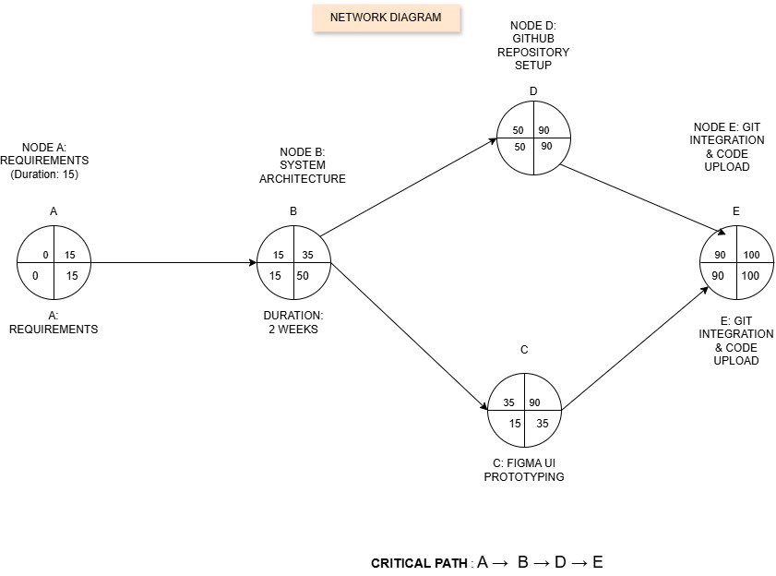
0 Use Case Specification: FarmSmart SL Platform

​4.1 Introduction to Use Case Modeling

​In object-oriented software engineering design, a UML Use Case specification defines the functional boundaries of a system by mapping user interactions against system behaviors. To align with the architectural workflow of the FarmSmart SL mobile prototype, this model captures how actors initiate system functionalities across the application's interface.

​4.2 System Actors

​The system boundary defines two primary entities interacting with the environment:

​Farmer (Primary Actor): The frontline end-user in Sierra Leone responsible for managing crop logs, tracking local supply shipments, and monitoring financial wallet parameters.

​System Administrator (Secondary Actor): The technical backend operator responsible for validating data persistence layers, monitoring delivery status flows, and maintaining secure data records.

​4.3 Detailed Use Case Specifications

​Use Case 1: User Authentication & Login

​Description: Governs how users access the secure boundaries of the platform using pre-existing profile credentials.

​Corresponding UI Screen: iPhone 17 - 1 (Get Started) and iPhone 17 - 2 (Welcome Back / Login).

​Main Flow:

​The Farmer interacts with the initial landing frame and selects "Get Started".

​The system prompts the user with input fields for an email or phone number and password on the login frame.

​The system validates the entry against the backend.

​Upon successful validation, the user session initializes, and the viewport navigates to the core dashboard view.

​Use Case 2: Secure User Account Creation

​Description: Enables unregistered farmers to create a verified digital profile on the system.

​Corresponding UI Screen: iPhone 17 - 3 (Create Account).

​Main Flow:

​The user selects the registration link from the primary login frame.

​The system presents input forms requiring Full Name, Email Address, and Password creation.

​The Farmer enters their information and taps "Register".

​The system validates the account constraints, saves the profile data to the database, and routes them to the landing dashboard.

​Use Case 3: Add New Supply & Quantity

​Description: Allows authenticated farmers to log newly harvested crop yields into the marketplace supply stream.

​Corresponding UI Screen: iPhone 17 - 11 (Home Menu), iPhone 17 - 4 (Dashboard Overview), and iPhone 17 - 5 (Add New Supply Form).

​Main Flow:

​The Farmer selects "Add New Supply" from the application navigation links.

​The system serves an entry form detailing Crop Name, Quantity, Location, and Expected Market Price.

​The user populates the variables and taps "Submit".

​The application pushes the entry data to the centralized inventory tracking layer.

​Use Case 4: Track Delivery Status

​Description: Provides real-time visibility into logistical progress as crop items move from local farms to regional market hubs.

​Corresponding UI Screen: iPhone 17 - 6 (Delivery Status tracker).

​Main Flow:

​The user accesses the "Delivery Status" utility from their main dashboard layout.

​The system issues a backend query to retrieve active shipping metadata.

​The UI renders a sequential tracking visualization showing milestone checkpoints: Order Confirmed, Dispatched, In Transit, and Arrived at Market Hub.

​Use Case 5: Generate & View Payment Receipt

​Description: Displays financial confirmation documents detailing transaction outputs once a crop shipment hits its destination.

​Corresponding UI Screen: iPhone 17 - 7 (Payment Receipt voucher).

​Main Flow:

​Upon reaching the market hub, the platform compiles transaction details.

​The user selects the transaction entry from their dashboard history.

​The system generates a visual digital receipt detailing the Order ID, Item details, Quantity settings, Storage status, and the Final Total Payout.

​Use Case 6: Manage Profile & Wallet

​Description: Allows farmers to monitor digital wallet balances and inspect personal account configuration parameters.

​Corresponding UI Screen: iPhone 17 - 8 (My Profile & Wallet).

​Main Flow:

​The Farmer navigates to the profile and wallet segment via the main navigation hub.

​The platform displays active user parameters including Total Balance, Farmer Name, Location, and Account Type.

​The user can review financial metrics or opt to initialize a session sign-out.

​Use Case 7: Configure App Settings & Support

​Description: Permits configuration of system options, localization parameters, and displays administrative alignments.

​Corresponding UI Screen: iPhone 17 - 9 (Setting & Support) and iPhone 17 - 10 (About FarmSmart SL).

​Main Flow:

​The user navigates to the app configurations interface.

​The system serves toggles for Push Notifications, language selection, and contact links to customer support.

​Accessing the "About" pane renders structural alignments mapping the application's targets directly to Sustainable Development Goals (SDG 2: Zero Hunger and SDG 12: Responsible Consumption & Production).

​Use Case 8: Secure Session Logout

​Description: Destroys active validation tokens and clears local cache files to protect user account integrity.

​Corresponding UI Screen: iPhone 17 - 8 (My Profile & Wallet interface).

​Main Flow:

​The user clicks the designated "Log Out" button.

​The application requests session termination from the hosting layer.

​The server invalidates the active runtime token.The application clears current user states and reverts the interface back to the baseline welcome viewport

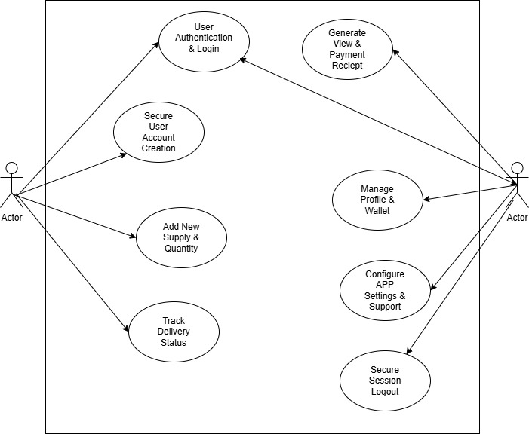

License, Design Quality & SDG Relevance

Software License
FarmSmart SL is released under the MIT License. The MIT License is a free and open-source software license that permits any person or organisation to use, copy, modify, merge, publish, distribute, and contribute to the system without restriction. This license was selected because FarmSmart SL is designed as a Digital Public Good intended to benefit farming communities across Sierra Leone. By using the MIT License, the system remains freely accessible to farmers, buyers, government agencies, and non-governmental organisations who may wish to adopt or improve the platform. The only requirement of the MIT License is that the original copyright notice and license text must be included in any copies or distributions of the software. All external resources and libraries used in the development of FarmSmart SL have been properly attributed in accordance with their respective licenses.

Design Quality (UI/UX)
The user interface of FarmSmart SL was designed using Figma, following the principles of simplicity, consistency, and accessibility. The design prioritises ease of use for farmers and buyers in Sierra Leone, including those in rural areas who may have limited experience with digital technology. Key design decisions include the use of large, clearly labelled buttons, simple navigation menus, and a clean colour scheme using green tones to reflect the agricultural nature of the platform. All ten screens maintain a consistent layout and visual style to ensure a smooth and familiar user experience throughout the application. The design also considers mobile responsiveness, ensuring that the interface functions well on both smartphones and desktop browsers.

SDG Relevance
FarmSmart SL directly addresses two United Nations Sustainable Development Goals. The primary goal is SDG 2: Zero Hunger, which aims to end hunger, achieve food security, improve nutrition, and promote sustainable agriculture. By providing farmers with a digital marketplace to list and sell their produce directly to buyers, FarmSmart SL eliminates unnecessary middlemen, reduces food waste, and ensures that agricultural products reach consumers more efficiently. This contributes to improved food security across Sierra Leone.
The secondary goal is SDG 1: No Poverty, which aims to end poverty in all its forms. Many farmers in Sierra Leone earn very low incomes due to limited access to markets and fair pricing. FarmSmart SL empowers farmers by giving them direct access to a wider market, allowing them to set fair prices for their products and increase their earnings. This directly contributes to reducing poverty in rural farming communities and improving the livelihoods of smallholder farmers across the country.

Conclusion
FarmSmart SL represents a practical and impactful digital solution to one of Sierra Leone's most pressing challenges: connecting smallholder farmers to buyers efficiently and fairly. Through the application of Agile SDLC principles, a well-structured 3-tier system architecture, a user-friendly Figma prototype, and careful project planning, the team has demonstrated a complete software design that is ready for development and deployment.
The system is built on open-source principles under the MIT License, making it freely available to all stakeholders including farmers, buyers, NGOs, and government agencies. Its alignment with SDG 1 and SDG 2 ensures that FarmSmart SL is not just a software project but a genuine contribution to the social and economic development of Sierra Leone.
The project was collaboratively developed and version-controlled using GitHub, ensuring transparency, teamwork, and organised file management throughout the development process.

References
1.United Nations. (2015). Sustainable Development Goals. Retrieved from https://sdgs.un.org/goals
2.Agile Alliance. (2023). What is Agile? Retrieved from https://www.agilealliance.org/agile101/
3. Open Source Initiative. (2023). The MIT License. Retrieved from https://opensource.org/licenses/MIT
4. Figma Inc. (2024). Figma Design Tool. Retrieved from https://www.figma.com.

